**Industrial Internship Report on**

**“Banking Information System”**

**Prepared By**

**Harshit Sharma**

|  |
| --- |
| *Executive Summary* |
| This report provides details of the Industrial Internship provided by upskill Campus and The IoT Academy in collaboration with the industrial partner UniConverge Technologies Pvt. Ltd. (UCT).  This internship was focused on a project/problem statement provided by UCT. We had to finish the project including the report in 6 weeks’ time.  My project was Banking Information System which is a prototype of a Banking System with functionalities from Bank Account creation to ATM transactions.  This internship gave me a very good opportunity to get exposure to industrial problems and design/implement solution for that. It was an overall great experience to have this internship. |

Table of Contents

1. Preface 3

2. Introduction 4

2.1 Background and context of the project 4

2.2 Importance of Banking Information Systems 5

2.3 Scope and objectives of the project 6

2.4 References 7

2.5 Glossary 7

3. Problem Statement 8

4. Existing and Proposed solution 9

5. Proposed Design/Model 11

5.1 High Level Diagram 11

5.2 Interfaces 13

6. Performance Test 14

6.1 Test Plan/Test Cases 15

6.2 Test Procedure 15

6.3 Performance Outcome 16

7. My learnings 17

8. Future work scope 18

# 1. Preface

The “Banking Information System Project Report” presents a comprehensive overview of the development and implementation of the project over the 6 weeks. Each week included some progress in the development of the application and planning for the enhancements for the next week. All In the pages that follow, we delve into the intricacies of our Banking Information System, outlining its objectives, design principles, development methodology, and the challenges we encountered along the way. From conceptualization to deployment, every stage of this project offered unique insights and learning opportunities that have enriched our understanding of both banking operations and software engineering. The Banking Information System project aims to develop a prototype of a banking as well as ATM simulation system. The prototype demonstrates the core features and flow of the system, showcasing its functionality and usability.

I owe my gratitude to the **upskill Campus** and **The IoT Academy** along with the industrial partner **UniConverge Technologies (UCT)** for providing me with this internship opportunity which was a 6-week internship program in which I was guided by the help team of the upskill Campus in almost all tasks, from reminders for submitting weekly progress report to attempting quizzes.

From this opportunity I learned how to interact with cooperate professionals and well as I learned new technologies that were used to develop my project. I give my best wishes to my juniors and other peers that are working or in future will get the opportunity to work with upskill Campus.

# 2. Introduction

## 2.1 Background and context of the project

As technological advancements continue to reshape industries, the banking sector has embraced digital transformation to enhance efficiency, accessibility, and customer experience. The Banking Information System project was conceived against the backdrop of this evolving financial landscape, where the convergence of finance and technology is reshaping the way banking services are delivered and managed. The project aimed to address the challenges and opportunities presented by this transformation by designing, developing, and implementing a robust and cutting-edge information system prototype tailored to the specific needs of modern banking operations.

**(I) Challenges in Traditional Banking:**

Traditional banking systems often suffer from manual processes, limited accessibility, and delayed responses. These limitations can result in inefficiencies, errors, and hindered customer experiences. Moreover, as the volume of transactions and data continues to grow exponentially, conventional methods of managing accounts, transactions, and customer interactions become increasingly inadequate. This project acts as a prototype to understand the procedures as well as the operations of the Banking System and ATM Machine.

**(II) Customer-Centric approach**

In an era of increased competition, banks are focusing on providing exceptional customer experiences to differentiate themselves in the market. The project emphasized the need to incorporate features that enhance customer interactions. Overall, the Banking Information System project aimed to bridge the gap between traditional banking practices and the demands of the digital age. This project can be considered as a building block for the development of a fully functioning Banking System that consists of more functions and large user base.

## 2.2 Importance of Banking Information Systems

In the dynamic and rapidly evolving landscape of modern banking, the development of a Banking Information System (BIS) prototype holds immense significance. A prototype serves as a preliminary version of the system, offering a tangible representation of the envisioned solution before the full-fledged implementation takes place. Here’s a deeper exploration of the importance of the Banking Information System prototypes:

**(I) Clarifying requirements and expectations:**

By providing a tangible representation, prototypes serve as a medium for discussions, feedback, and refinement. This iterative process ensures that both the development team and the customers are aligned on the project's scope, functionalities, and overall objectives. These discussions remove all the mis-understandings in the requirement analysis that are created due to lack of clarifications between developers and the collaborators.

**(II) Enhancing User Interface (UI)/User Experience (UX) Design:**

The user experience is a critical aspect of any banking system. A prototype allows designers to create user interfaces that are intuitive, easy to navigate, and tailored to the needs of end-users. By simulating interactions, designers can refine UI elements, ensuring a seamless and user-friendly experience. The better the interface of the application will be, the more the customer base will increase. Since banking operations are very crucial and many people are afraid in performing banking through digital means, so it becomes more important for the interface of the banking application to be more and more user friendly. This can only be achieved firstly creating a prototype of the system and taking feedbacks from the users or project collaborators.

## 2.3 Scope and objectives of the project

The scope and objectives of the Banking Information System (BIS) project define the boundaries within which the project will operate and the specific outcomes it aims to achieve. These aspects provide a clear roadmap for the project's execution, ensuring that it stays focused on delivering value to collaborators.

**(I) Scope of the project:**

The scope of the Banking Information System project encompasses a comprehensive revamp of the bank's existing technology infrastructure to create an integrated, efficient, and user-friendly digital ecosystem. The project includes the development and implementation of a robust software solution that covers multiple aspects of banking operations, from customer interactions to backend processes. The scope extends to the following key areas:

* **Account Management**
* **Transaction Processing**
* **Prototype development for a Banking System**

**(II) Objectives of the project:**

The objectives of the Banking Information System project are designed to address the challenges faced by the bank's existing systems, improve operational efficiency, enhance customer experience, and position the institution for growth and innovation in the digital era. The main objective of this project is almost clear that is to make it easy for new users to create and manage their accounts without and hassle. The project aims to achieve the following key objectives:

* **Streamline Operations**
* **Enhance Customer Experience**
* **Enable real-time transactions**
* **Prepare for scalability**

## 2.4 References

1. <https://www.codementor.io/>
2. <https://stackoverflow.com/>
3. <https://www.codeproject.com/>
4. <https://sourceforge.net/>
5. <https://www.codeguru.com/>
6. <https://coderanch.com/>
7. <https://stackexchange.com/>
8. <https://www.youtube.com/>

## 2.5 Glossary

|  |  |
| --- | --- |
| **Terms** | **Acronym** |
| JDBC | Java Database Connectivity |
| JFrames | Java Frames |
| AWT | Abstract Window Toolkit |
| UI | User Interface |
| UX | User Experience |
| BIS | Banking Information System |

# 3. Problem Statement

In the rapidly evolving landscape of the financial industry, the need for an advanced and efficient Banking Information System (BIS) has become increasingly critical. As banks and financial institutions strive to enhance customer experiences, streamline operations, and maintain regulatory compliance, the limitations of existing legacy systems have become evident. This project aims to address the challenges posed by outdated banking systems in which most of the banking procedures are done manually. But this project builds a prototype for the digital banking system by designing and implementing a modern Banking Information System. The current banking systems in place suffer from several interconnected problems. These include:

**(I) Operational Inefficiencies:** The existing systems rely on disjointed processes, manual data entry, and redundant workflows, leading to time-consuming transactions and operational inefficiencies. This results in prolonged customer wait times, increased error rates, and unnecessary resource allocation.

**(II) Limited Accessibility and Convenience:** Customers are demanding seamless digital experiences that allow them to perform banking activities from anywhere, at any time. The lack of an integrated digital platform hinders accessibility, preventing customers from conducting transactions, accessing account information, and managing finances conveniently.

# 4. Existing and Proposed solution

**(I) Existing Solutions**

The current banking system in use is rooted in traditional technologies and methods that have progressively hindered the bank's ability to keep pace with the dynamic demands of the modern financial landscape. Although some banks are upgrading their systems, but most of the banks rely on primitive systems. The existing solution is characterized by:

1. **Legacy Infrastructure:** The bank relies on an outdated IT infrastructure comprising disparate systems that lack integration, leading to wrong data and disjointed operations.
2. **Manual Processes**: Many critical banking processes, such as customer onboarding, transaction processing, and account maintenance, are heavily reliant on manual data entry and paper-based documentation, resulting in inefficiencies and errors.
3. **Limited Digital Presence**: While the bank offers some online services, the digital channels are basic and do not provide a comprehensive range of features that customers expect in today's digital age.
4. **Scalability Challenges**: The existing systems lack the flexibility and scalability required to accommodate the bank's growth and adapt to new technologies, hindering the introduction of innovative products and services.

**(II) Proposed Solutions**

To address the limitations of the current banking system and align with industry best practices, the proposed solution entails the development and implementation of an advanced Banking Information System (BIS). This prototype will provide a base for developing a transformative solution with leverage cutting-edge technologies and methodologies to revolutionize the bank's operations, enhance customer experiences. The key components of the proposed prototype include:

1. **Integrated Digital Platform:** The new BIS prototype will provide customers with to perform a wide range of banking activities, from fund transfers to loan applications, at their convenience.
2. **Automated Workflows:** By automating core banking processes, the new system will significantly reduce manual interventions, leading to streamlined operations, quicker transactions, and a substantial decrease in error rates.
3. **Digital ATM facilities:** This BIS prototype provides users with a digital ATM Simulator that can be connected with the user account to provide ATM transactions remotely through smartphones or computers.
4. **Digital Account Creation Facility:** This prototype also proposes a facility to create a new account by filling the account opening forms digitally from any remote location instead of filling it manually at a particular branch of any particular bank.
5. **Data Centralization**: The proposed solution emphasizes centralized data storage and management, ensuring that all customer data is consistently updated and available in real time across the organization.
6. **Scalable Database:** This prototype suggests the use of a scalable database that can be used to fulfil the growing demands of the increasing users of the application.

**4.1 Code and Report Submission (GitHub Link):**

In order to provide easy access to the complete project report and associated materials, we have prepared a GitHub repository where you can find the finalized version of this report, along with relevant code, data, and additional resources.

[GitHub/harshit-nh/Banking-Information-System](https://github.com/harshit-nh/Banking-Information-System)

# 5. Proposed Design/Model

The system design of the BIS prototype was created keeping in mind hassle-free banking operations for the users. The data flow of the system starts from one Java Frame to another. This flow control of the system can be represented with the help of High-Level and Low-Level Designs of the prototype.

## 5.1 High Level Diagram

1. **BIS** **Flow Chart**

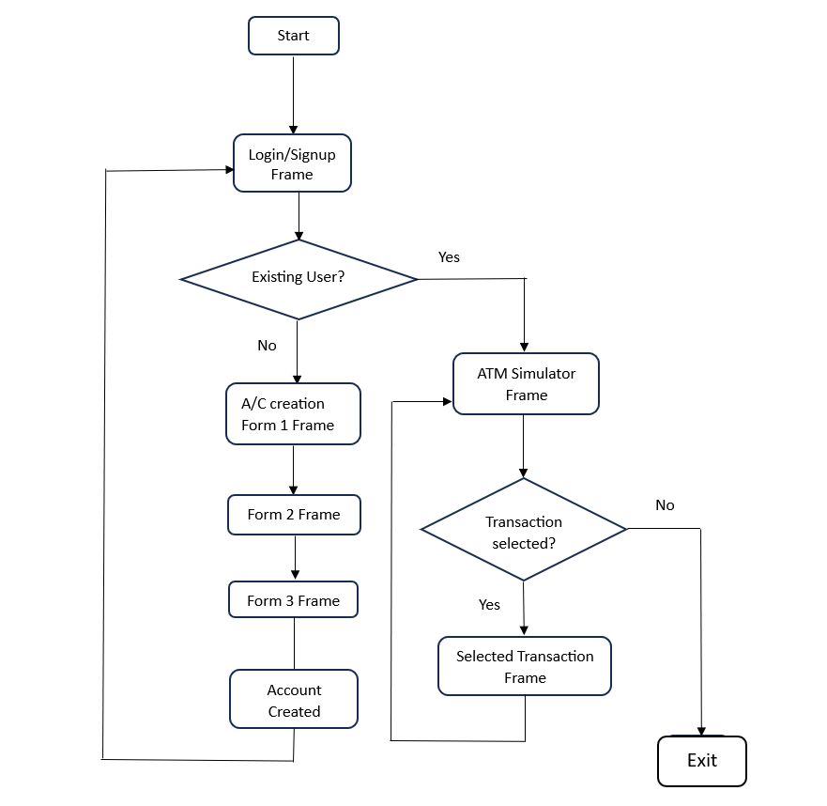

**(b) Account Creation Sequence Diagram**

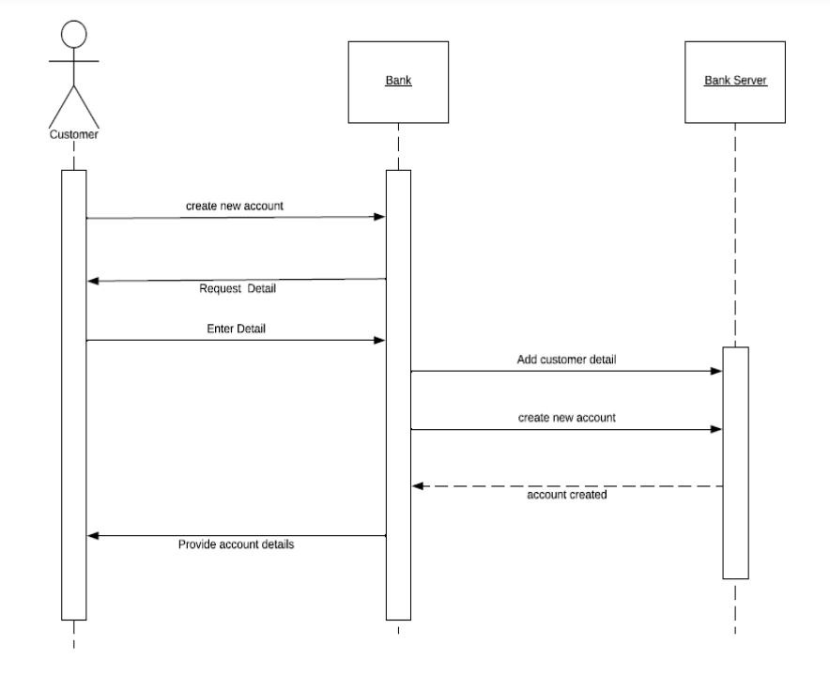

## 5.2 Interfaces

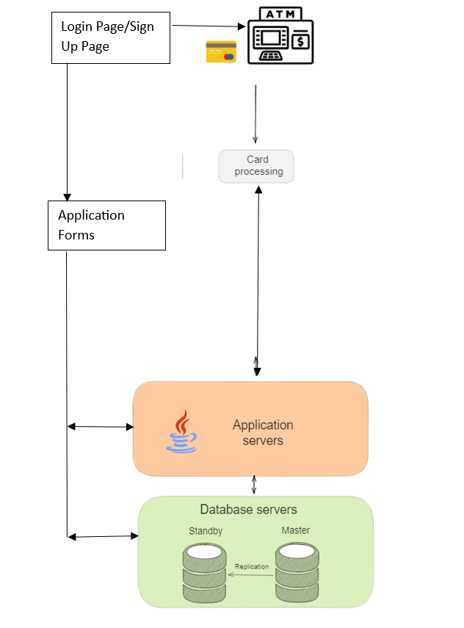

# 6. Performance Test

The "Performance Test" section of this report elucidates the meticulous evaluation of the Banking Information System's performance while adhering to specific constraints. This section plays a pivotal role in establishing the system's practical utility within the realm of banking operations, transcending academic exercises. Although this project may not look like a fully functioning application so far, but this project can be considered as a prototype for developing a fully-fledged application.

**(I) Identification of Constraints**

In the context of the Banking Information System, the constraints that govern its performance have been carefully identified. These constraints encompass various dimensions including memory utilization, processing speed (MIPS), accuracy of financial calculations, system durability, and power consumption.

**(II) Addressing Constraints in Design**

The design of the Banking Information System, realized through the Java AWT framework, takes into account the unique requirements of the identified constraints. To manage memory effectively, the application employs optimized data structures to minimize memory overhead during account management and transaction processing. The Java AWT's lightweight nature ensures efficient rendering and responsiveness, contributing to a seamless user experience. The integration of a MySQL database caters to durability concerns, ensuring data integrity and robustness.

## 6.1 Test Plan/Test Cases

For the performance testing phase of our Banking Information System project, we have formulated a comprehensive test plan that outlines the objectives and approach for assessing system performance. This includes creating detailed test cases for various scenarios, such as account creation, balance inquiries, and ATM transactions.

Example Test Cases:

1. Simulate multiple concurrent account creation requests to assess the system's response time and resource utilization.
2. Execute a series of ATM transactions involving withdrawals, balance inquiries, and fund transfers to different accounts.

## 6.2 Test Procedure

During the performance testing phase, I followed a structured procedure to execute the defined test cases. The Banking Information System was deployed on a dedicated testing environment to replicate real-world usage conditions.

Example Test Procedure:

1. Set up the test environment with the Banking Information System connected to the MySQL database using JDBC.
2. Execute the predefined test cases, each representing a specific transaction type, with varying load levels.
3. Monitor system resources, response times, and database queries during the test execution.
4. Record the outcomes, including response times, transaction success rates, and any anomalies observed.

## 6.3 Performance Outcome

The performance testing yielded valuable insights into the Banking Information System's capabilities and efficiency under different scenarios. The outcomes provide an understanding of how well the system handles user interactions and transactions, thereby ensuring a seamless experience for users.

Example Performance Outcomes:

1. Account Creation Speed: The system demonstrated a rapid account creation process, with an average response time of 2 seconds.
2. ATM Transaction Speed: ATM transactions, including withdrawals and balance inquiries, were executed within an average of 3 seconds.
3. Scalability: The system exhibited scalability by maintaining consistent performance even under high load conditions.

In summary, the performance testing phase of our Banking Information System project involved thorough planning, test case formulation, meticulous execution, and detailed analysis of outcomes. This ensured that the system meets performance expectations and operates efficiently, enhancing the user experience and overall system reliability.

# 7. My learnings

Throughout the whole month that I spent working on this project due to the internship opportunity given by upskill Campus, I learnt a lot of skills in many ways, including not only technical skills but also project report making, time management, trying to indulge into work like a corporate professional and many others that may be could not be mentioned but have been acquired by my own self.

Talking about this project, I learnt how to use Java AWT framework along with connecting it with MySQL using JDBC technology. These technologies are in high demand these days, so acquiring them will be surely beneficial for me. I also learnt using MySQL Workbench, creating different databases, implementing different queries, etc.

The project presented me with numerous challenges that required innovative problem-solving. Debugging, troubleshooting, and finding efficient solutions became second nature. I learned to approach issues systematically, breaking down complex problems into manageable components.

Throughout the project, we realized that technology is ever-evolving. Staying up-to-date with the latest advancements in Java, databases, and software development practices became a continuous endeavour.

In conclusion, the "My Learning" section encapsulates the growth, challenges, and achievements that marked my journey through the development of the Banking Information System project. The lessons gained from this experience are invaluable, serving as a foundation for my continuous growth as a software developer and a problem solver.

# 8. Future work scope

While the current iteration of the Banking Information System project has successfully encompassed various features such as account creation, ATM simulation, and user-friendly interfaces, there are areas that were not fully realized due to the constraints of time and resources. One notable feature that was not included in the current project is the **Fund transfer** functionality.

Moving forward, the implementation of the fund transfer functionality will require careful planning and development. This includes considerations for security, transaction validation, user authentication, and integration with the existing system components. I intend to leverage the technical knowledge gained during this project to ensure the successful implementation of this feature.

The absence of the fund transfer functionality serves as a reminder of the dynamic nature of software development projects and the need for continuous improvement. While the current project serves as a foundation, I am excited about the prospects of enhancing the system's capabilities and offering users a comprehensive banking experience that encompasses all essential transactions.